

**PYTHON LAB MANUAL**

**Lab Code:- 6CS4-23**

**(III Year B.Tech. VI Sem)**

**Session 2020-21**



**Department of Computer Science & Engineering**

**RIET, JAIPUR**

**Submitted to:** **Submitted by:**

MR.DINESH SWAMI Vicky Kumar

ASSISTANT PROFESSOR 18ERECS080 (CSE)

Sem-6th

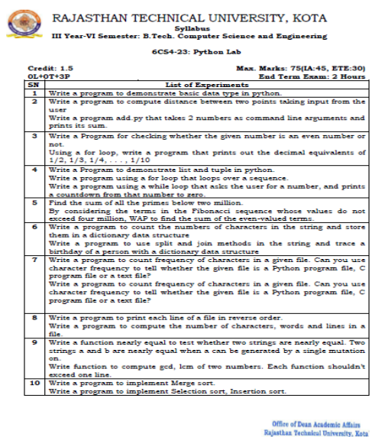

**Experiment 1**

**Aim: Write a program to demonstrate basic data type in python.**

**Code:**

a = 5

print("Type of a: ", type(a))

b = 5.0

print("\nType of b: ", type(b))

c = 2 + 4j

print("\nType of c: ", type(c))

# Creating a String

String1 = 'Welcome to the RIET Jaipur '

print("String with the use of Single Quotes: ")

print(String1)

# Creating a List with

List = ["RIET", "JAIPUR", "RAJ"]

print("\n List containing multiple values: ")

print(List[0])

print(List[2])

# Creating a Set set1 = set()

set1.add(8) # Creating a Tuple with

the use of list list1 = [1, 2, 4, 5, 6]

print("\nTuple using List: ")

print(tuple(list1))

set1.add(9)

set1.add((6, 7))

print("\nSet after Addition of Three elements: ")

print(set1)

**Output:**

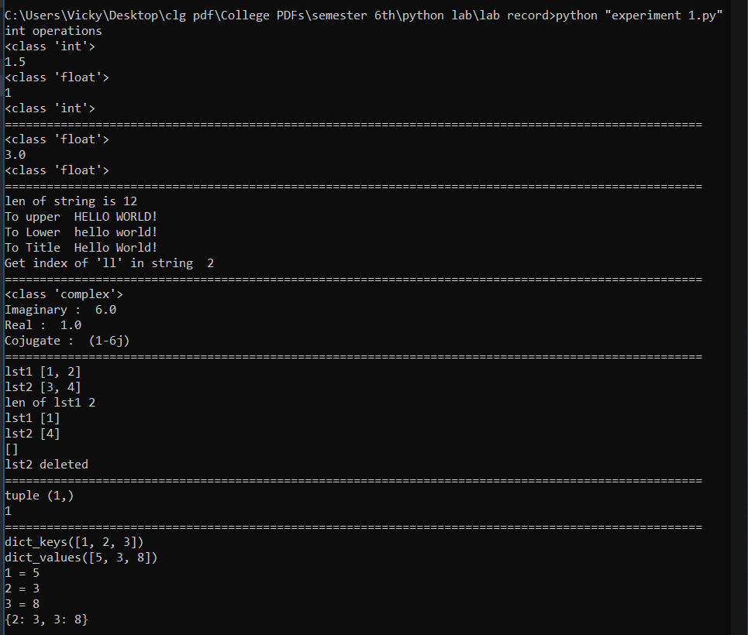

**Experiment 2**

**Aim: (a) Write a program to compute distance between two points taking input from the user. Code:**

import math

a=int(input("Enter first value"))

b=int(input("Enter second value"))

c=math.sqrt(a**2+b**2)

print("Distance=",c)

**Output:**

Enter first value5

Enter second value6

Distance= 7.810249675906654

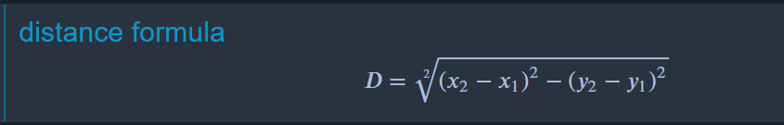

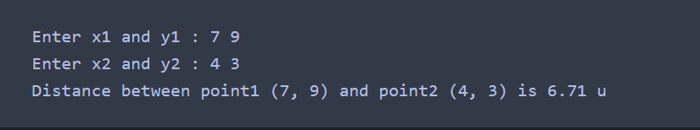

**Aim: (b) Write a program add.py that takes 2 numbers as command line arguments and prints its sum.**

**Code:**

import sys

a=int(sys.argv[1])

b=int(sys.argv[2])

c=a+b

print("Sum=",c)

**Output:**

python add.py 4 5

Sum= 9

**Experiment 3**

**Aim: (a) Write a Program for checking whether the given number is an even number or not. Code:**

num = int(input("Enter a number: "))

if(num%2==0):

print("This is an even number.")

else:

print("This is an odd number.")

**Output:**

Enter a number: 4

This is an even number.

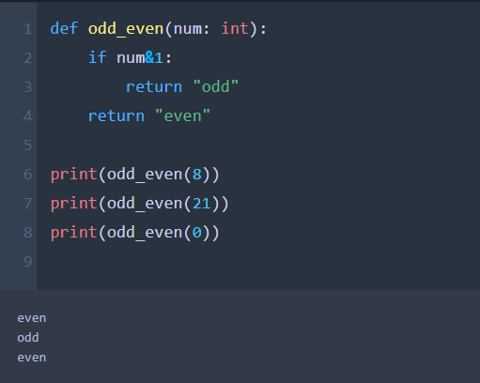

**Aim: (b) Using a for loop, write a program that prints out the decimal equivalents of 1/2, 1/3, 1/4, . . . , 1/10.**

**Code:**

for i in range(1,11):

print ("Decimal equivalent value for 1/",i," is",1/float(i))

**Output:**

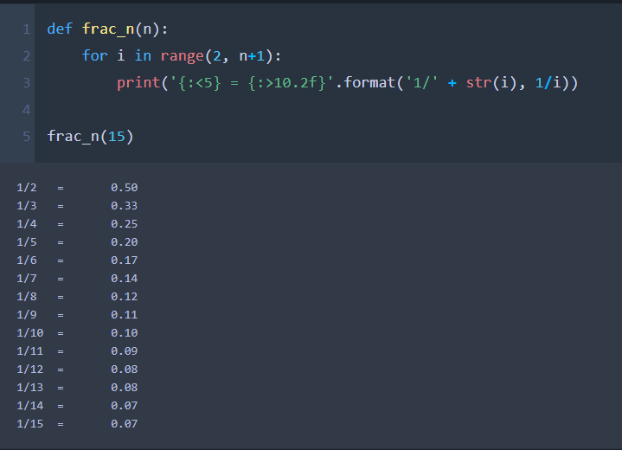

**Experiment 4**

**Aim: (a) Write a Program to demonstrate list in python (We are given an array of n distinct numbers, the task is to sort all even-placed numbers in increasing and odd-place numbers in decreasing order. The modified array should contain all sorted even-placed numbers followed by reverse sorted odd-placed numbers.)**

**Code:**

def evenOddSort(input):

# separate even odd indexed elements list

evens = [ input[i] for i in range(0,len(input)) if i%2==0 ]

odds = [ input[i] for i in range(0,len(input)) if i%2!=0 ]

# sort evens in ascending and odds in descending using sorted() method

print (sorted(evens) + sorted(odds,reverse=True))

input = [0, 1, 2, 3, 4, 5, 6, 7]

evenOddSort(input)

**Output:**

[0, 2, 4, 6, 7, 5, 3, 1]

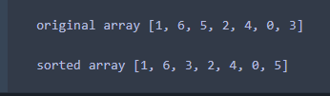

**Aim: (b) Write a Program to demonstrate tuple in python (Given a list of tuples, Write a Python program to remove all the duplicated tuples from the given list).**

**Code:**

def removeDuplicates(lst):

return [t for t in (set(tuple(i) for i in lst))]

# Driver code

lst = [(1, 2), (5, 7), (3, 6), (1, 2)]

print(removeDuplicates(lst))

**Output:**

[(1, 2), (5, 7), (3, 6)]

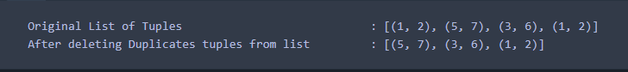

**Aim: (c) Write a program using a for loop that loops over a sequence.**

**Code:**

players=["kohli", "dhoni", "sachin", "sehwag", "Dravid"]

for i in players:

print (i)

**Output:**

kohli

dhoni

sachin

sehwag

Dravid

**Aim: (d) Write a program using a while loop that asks the user for a number, and prints a countdown from that number to zero.**

**Code:**

n=int(input("Enter the number for countdown: "))

while (0<=n):

print (n, end=" ")

n=n-1

**Output:**

Enter the number for countdown: 15

15 14 13 12 11 10 9 8 7 6 5 4 3 2 1 0

**Experiment 5**

**Aim: (a) Find the sum of all the primes below two million.**

Code:

n = 2000000

prime = [True for i in range(n+1)]

p = 2

while (p * p <= n):

if (prime[p] == True):

for i in range(p * p, n+1, p):

prime[i] = False

p += 1

sum=0

for p in range(2, n):

if prime[p]:

sum=sum+p

print("sum=", sum)

Output:

sum= 142913828922



**Aim: (b) By considering the terms in the Fibonacci sequence whose values do not exceed four million, WAP to find the sum of the even-valued terms.**

Code:

limit = 4000000

if (limit < 2):

print("Sum=0")

else:

ef1 = 0

ef2 = 2

sm= ef1 + ef2

while (ef2 <= limit):

ef3 = 4 * ef2 + ef1

if (ef3 > limit):

break

ef1 = ef2

ef2 = ef3

sm = sm + ef2

print("Sum=",sm)

Output: Sum= 4613732



**Experiment 6**

**Aim: (a) Write a program to count the numbers of characters in the string and store them in a dictionary data structure.**

Code:

def char_frequency(str1):

dict = {}

for n in str1:

keys = dict.keys()

if n in keys:

dict[n] += 1

else:

dict[n] = 1

return dict

print(char_frequency('google.com'))

Output:

{'c': 1, 'e': 1, 'g': 2, 'm': 1, 'l': 1, 'o': 3, '.': 1}



**Aim: (b) Write a program to use split and join methods in the string and trace a birthday of a person with a dictionary data structure.**

**Code:**

dob={"mothi":"12-11-1990","sudheer":"17-08-1991","vinay":"31-08-1988"}

str1=input("which person dob you want: ")

l=str1.split()

birth=""

for i in l:

if i in dob.keys():

name=i

print (" ".join([name,"Birthday is",dob[name]]))

Output:

which person dob you want: i want vinay dob

vinay Birthday is 31-08-1988

**Experiment 7**

**Aim: Write a program to count frequency of characters in a given file. Can you use character frequency to tell whether the given file is a Python program file, C program file or a text file?**

Code:

import os

f=open("deepa.py")

count=dict()

for line in f:

for ch in line:

if ch in count:

count[ch]=count[ch]+1

else:

count[ch]=1

print (count)

filename,file_extension=os.path.splitext("deepa.py");

print("file_extension==",file_extension);

if(file_extension=='.py'):

print("its python program file");

elif(file_extension==".txt"):

print("its a txt file");

elif(file_extension==".c"):

print("its a c program file");

f.close()

deepa.py:

my name is deepa modi

Output:

{'m': 3, 'y': 1, ' ': 4, 'n': 1, 'a': 2, 'e': 3, 'i': 2, 's': 1, 'd': 2, 'p': 1, 'o': 1}

file_extension== .py

its python program file

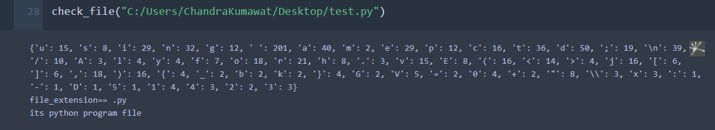

**Experiment 8**

**Aim: (a) Write a program to print each line of a file in reverse order.** Code:

filename=input("Enter the filename: ")

f=open(filename,"r")

for line in f:

line2=""

for ch in range(len(line)-1,-1,-1):

line2=line2+line[ch]

print(line2)

f.close()

deepa.py:

my name is deepa modi

i am a cool person

Output:

Enter the filename: deepa.py

idom apeed si eman ym

nosrep looc a ma i

**Aim: (b) Write a program to compute the number of characters, words and lines in a file.** Code:

filename=input("Enter the filename: ")

f=open(filename,"r")

l=w=c=0

for line in f:

words=line.split()

l=l+1

for word in words:

w=w+1

for ch in word:

c=c+1

print("No. of lines",l)

print("No. of words",w)

print("No. of characters",c)

f.close()

deepa.py:

my name is deepa modi

i am a cool person

Output:

Enter the filename: deepa.py

No. of lines 2

No. of words 10

No. of characters 31

**Experiment 9**

**Aim: (a) Write a function nearly equal to test whether two strings are nearly equal. Two strings a and b are nearly equal when a can be generated by a single mutation on.**

Code:

def mutate(word):

out_list = []

letters = 'abcdefghijklmnopqrstuvwxyz'

#insert a character

for i in range(len(word) + 1):

for j in range(26):

out_list.append(word[:i] + letters[j] + word[i:])

#deleting a character

for i in range(len(word)):

out_list.append(word[:i] + word[i + 1:])

#replace a character

for i in range(len(word)):

for j in range(26):

out_list.append(word[:i] + letters[j] + word[i + 1:])

#swapping a characters

current_word = []

out_word = ''

for i in range(len(word) - 1):

for j in range(i + 1, len(word)):

#converting string into list

cword = list(word)

#Swapping of characters in a list

cword[i], cword [j] = cword [j], cword [i]

#converting list into string

str1="".join(current_word)

out_list.append(str1)

return out_list

def nearly_equal(word1, word2):

if len(word1)<len(word2):

word1,word2=word2,word1

return word1 in mutate(word2)

else:

return word1 in mutate(word2)

a=input("Enter First Word: ")

b=input("Enter Second Word: ")

print(nearly_equal(a,b))

Output:

Enter First Word: deepa

Enter Second Word: dipa

False

Enter First Word: welcome

Enter Second Word: welcme

True

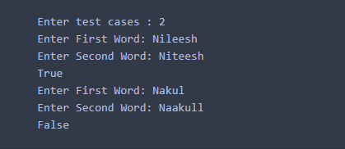

**Aim: (b) Write function to compute gcd, lcm of two numbers. Each function shouldn’t exceed one line.** Code:

def gcd(x,y):

return x if y==0 else gcd(y,x%y)

def lcm(x,y):

return (x*y)//gcd(x,y)

print ("gcd is",gcd(54,24))

print ("lcm is",lcm(54,24))

Output:

gcd is 6

lcm is 216

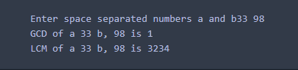

**Experiment 10**

**Aim: (a) Write a program to implement Merge sort.** Code:

def mergeSort(nlist):

#print("Splitting ",nlist)

if len(nlist)>1:

mid = len(nlist)//2

lefthalf = nlist[:mid]

righthalf = nlist[mid:]

mergeSort(lefthalf)

mergeSort(righthalf)

i=j=k=0

while i < len(lefthalf) and j < len(righthalf):

if lefthalf[i] < righthalf[j]:

nlist[k]=lefthalf[i]

i=i+1

else:

nlist[k]=righthalf[j]

j=j+1

k=k+1

while i < len(lefthalf):

nlist[k]=lefthalf[i]

i=i+1

k=k+1

while j < len(righthalf):

nlist[k]=righthalf[j]

j=j+1

k=k+1

#print("Merging ",nlist)

nlist = [14,46,43,27,57,41,45,21,70]

mergeSort(nlist)

print(nlist)

Output:

[14, 21, 27, 41, 43, 45, 46, 57, 70]

**Aim: (b) Write a program to implement Selection sort.** Code:

30

def selectionSort(nlist):

for fillslot in range(len(nlist)-1,0,-1):

maxpos=0

for location in range(1,fillslot+1):

if nlist[location]>nlist[maxpos]:

maxpos = location

temp = nlist[fillslot]

nlist[fillslot] = nlist[maxpos]

nlist[maxpos] = temp

nlist = [14,46,43,27,57,41,45,21,70]

selectionSort(nlist)

print(nlist)

Output:

[14, 21, 27, 41, 43, 45, 46, 57, 70]

**Aim: (c) Write a program to implement Insertion sort.** Code:

def insertionSort(nlist):

for index in range(1,len(nlist)):

currentvalue = nlist[index]

position = index

while position>0 and nlist[position-1]>currentvalue: nlist[position]=nlist[position-1]

position = position-1

nlist[position]=currentvalue

nlist = [14,46,43,27,57,41,45,21,70]

insertionSort(nlist)

print(nlist)

Output:

[14, 21, 27, 41, 43, 45, 46, 57, 70]